5.28 B-Tree Deletion in Data Structures | DSA Tutorials
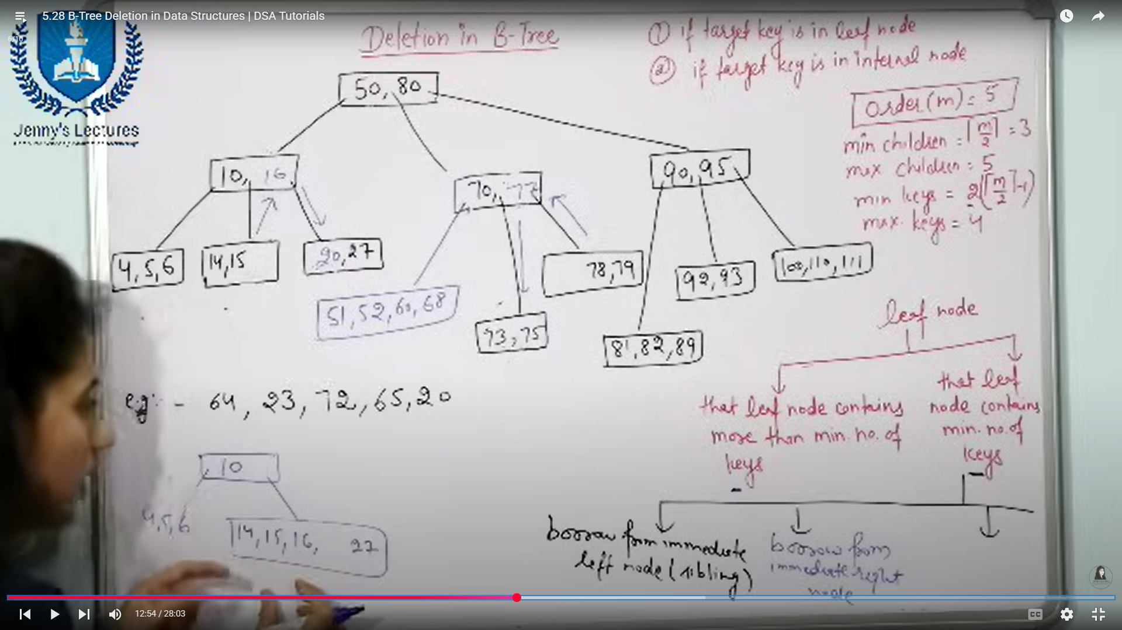
Deleting: key 20;
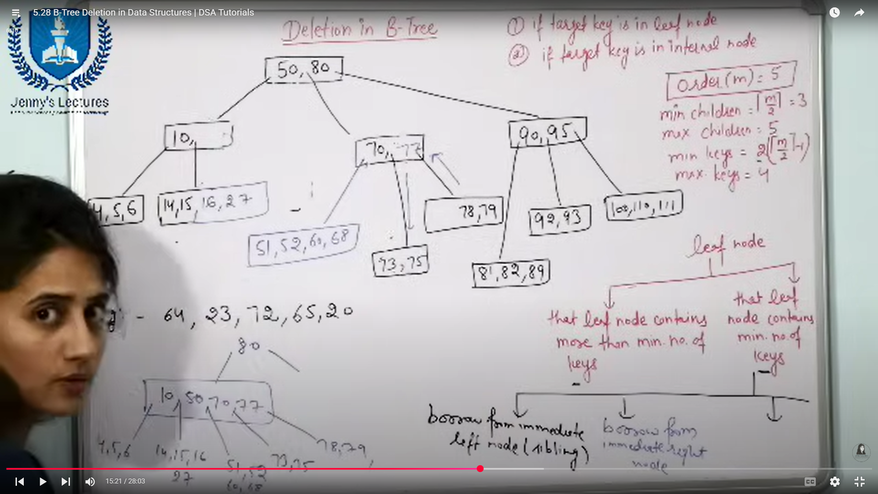
Implementation of DBMS
Exercise Sheet 9
Klingemann, WS 2024 / 2025
- Delete from a B+-tree:
Starting with the B+-tree of order 4 you created in task 1 of Sheet 8, delete the keys 45, 20, 10, 50, 35, 40, 60, 30, 25, 15, 70, 55, 90 in this order. Show the tree structure after each operation and describe any necessary redistributions or merges.
- Insert into a B-tree:
Insert the keys 100, 50, 25, 125, 75, 150, 30, 60, 40, 80, 120, 135 into an initially empty B-tree of order 2 and if have time order 3. Show the tree structure after each insertion and explain any splits.
- Delete from a B-tree:
From the B-tree of order 2 you produced in task 2, delete the keys 40, 60, 120, 25 in this order. Show the tree structure after each deletion and explain all redistributions or merges that occur.

Implementation of DBMS
Like Exercise Sheet 9
Klingemann, WS 2024 / 2025
- Insertions in a B+-Tree
Insert the keys 5, 15, 25, 35, 45, 10, 20, 30, 40, 50 into an initially empty B+-tree of order 3. After every insertion, show the structure of the tree and any splits that occur.
- Deletions in a B+-Tree
Starting with the B+-tree of order 3 produced in task 1, delete the keys 20, 40, 10, 25 in this order. Show the tree structure after each deletion and explain any merges or redistributions that occur.
- Insertions and Deletions in a B-tree
Insert the keys 12, 8, 18, 5, 15, 20, 10 into an initially empty B-tree of order 4. Then, delete the keys 15, 20, 8 in this order. Explain all structural changes, such as splits or merges, during both insertion and deletion operations.

Implementation of DBMS
Again, similar to Exercise Sheet 9
Klingemann, WS 2024 / 2025
- B+-Tree Operations
Starting with an initially empty B+-tree of order 4, insert the keys 2, 8, 12, 4, 6, 10, 14, 16, 18. After completing all insertions, delete the keys 12, 6, 14 in this order. Show the tree structure after each operation and explain any necessary redistributions or merges.
- B-tree Operations
Insert the keys 3, 9, 15, 7, 12, 1, 4 into an initially empty B-tree of order 3. Show the structure of the tree after all insertions. Then delete the keys 7, 4, 9 in this order and show how the tree changes.
- Compare B+-Tree and B-tree
Discuss the differences between the B+-tree and the B-tree structures produced in tasks 1 and 2 above. Focus on:
  - Handling of keys during splits and merges.
  - The organization of leaf and non-leaf nodes.
  - Use cases where B+-trees might be preferred over B-trees in database systems.

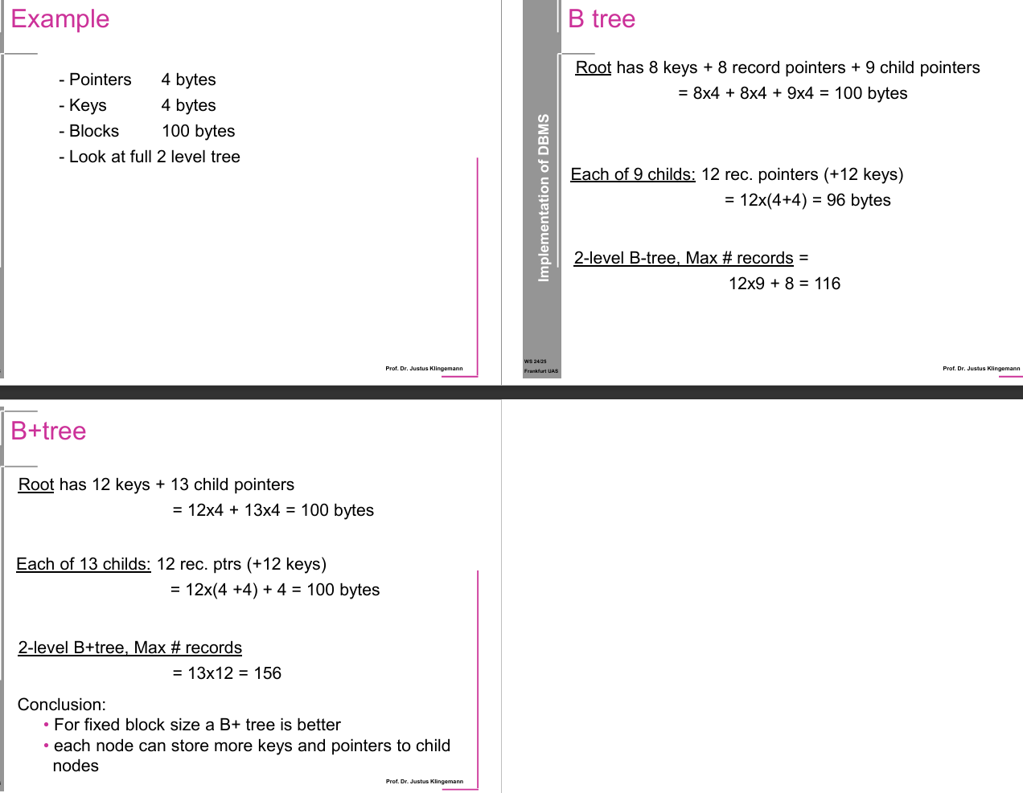
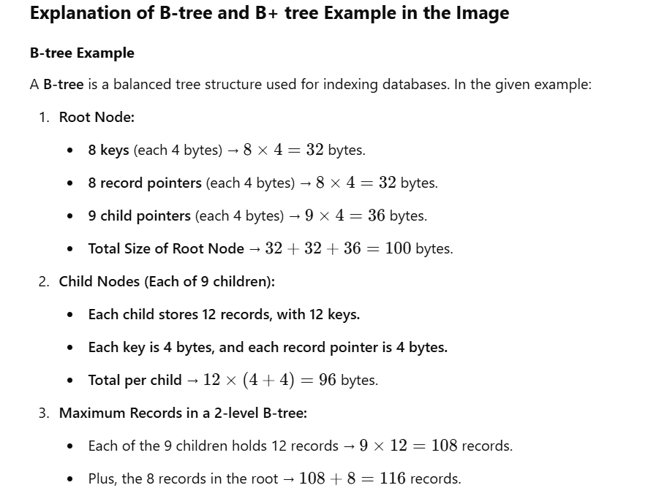
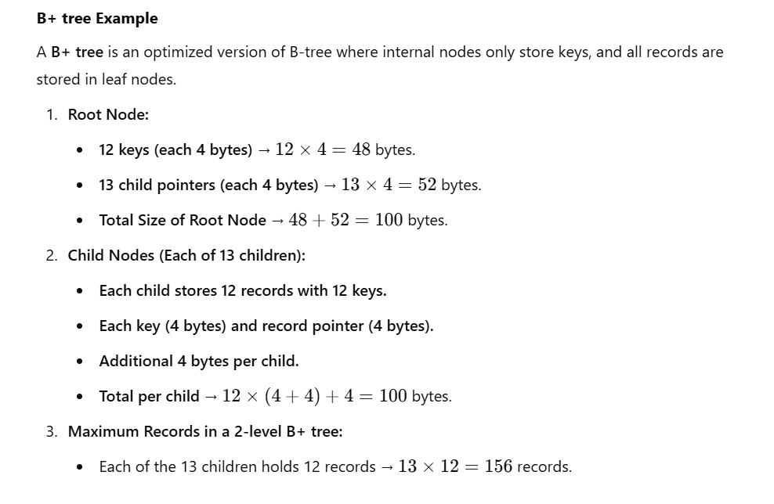
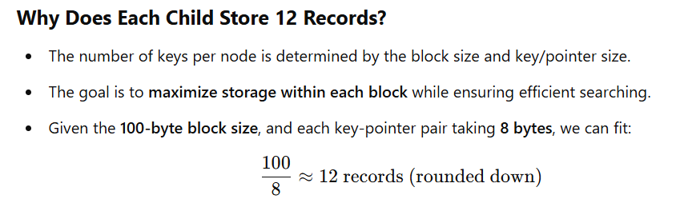

Conclusion
- The B+ tree can store more records in the same block size because internal nodes only store keys, allowing more efficient searches and faster range queries.
- For fixed block size, B+ trees are preferred because they store more keys and child pointers.

Three More Exercises

Exercise 1a:
Consider a B-tree where:
- Pointers are 8 bytes, keys are 8 bytes, and blocks are 200 bytes.
- The root node has 10 keys, 10 record pointers, and 11 child pointers.
- Each child node stores 15 records.
Tasks:
- Calculate the size of the root node.
- Compute the size of each child node.
- Find the maximum number of records in a 2-level B-tree.

Exercise 1b:
Consider a B+ tree where:
- Pointers are 6 bytes, keys are 6 bytes, and blocks are 150 bytes.
- The root node has 9 keys and 10 child pointers.
- Each child node holds 13 records.
Tasks:
- Compute the size of the root node.
- Calculate the size of each child node.
- Find the maximum number of records in a 2-level B+ tree.

Exercise 1c:
A B-tree variant has:
- Pointers: 5 bytes, Keys: 5 bytes, Blocks: 120 bytes.
- The root node contains 7 keys, 7 record pointers, and 8 child pointers.
- Each child node holds 10 records.
Tasks:
- Compute the size of the root node.
- Determine the size of each child node.
- Find the maximum number of records in a 2-level B-tree.

Example 1
- Pointers: 8 bytes
- Keys: 8 bytes
- Blocks: 200 bytes
- Look at full 2-level tree

Example 2
- Pointers: 6 bytes
- Keys: 6 bytes
- Blocks: 150 bytes
- Look at full 2-level tree

Example 3
- Pointers: 5 bytes
- Keys: 5 bytes
- Blocks: 120 bytes
- Look at full 2-level tree

